Microsoft Teams Quick Guide
(November 2025)

Roles in Teams Meeting
- Organizer: Full control, including managing breakout rooms, muting participants, and changing meeting options.
- Co-organizer: Shares many organizer permissions, such as muting participants, managing the meeting, and controlling breakout rooms. They don’t have access to the meeting recordings.
- Presenter: Can share content, manage Q&A, and assist with facilitating the meeting.
- Attendee: Limited to participating in the chat and viewing shared content, without control over the meeting.
- Unverified (guest): Seems to have some limits on the chat – can read, but not type. Cannot download from chat. Cannot vote on polls within the meeting. See How to Verify your Teams Account

Accessing Teams
Can use Teams through your internet browser (Microsoft Teams), OR through desktop app.
If Teams is already installed, go to Start Menu: Click the Windows icon at the bottom-left corner of your screen to access pinned apps. Select Teams.
If Teams is not installed on the desktop, you can install it from the internet browser Teams after you have logged in. Go to the upper right and click the 3 dots for settings. In the drop-down menu, select get the desktop app. (see photo below). Can also do this for mobile device.
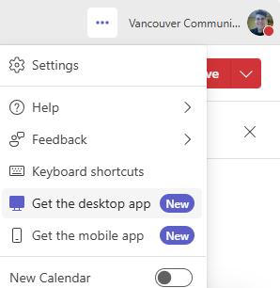

Feature | Zoom | Microsoft Teams Description | Video
Creating a recurring Teams meeting | Zoom  scheduler | Use Teams calendar to CREATE MEETING. Adjust the settings to the permissions you want (consider the lobby, who should have presenting/screen control rights, when meeting chat should be enabled). See Recommended Settings for Online Class in Teams. Create a recurring meeting so you only need one link for students for the term.  Verification! Participants need to be verified to access all the features of a meeting including typing in the chat, downloading chat files and participating in polls. See How to Verify your Teams Account | VCC Tutorial on creating Class meeting (old Teams calendar)  VCC Tutorial on creating meeting (new Teams calendar)
Adding a co-organizer | Co-host | To add a co-organizer, they must be an attendee who is already invited to the meeting event. Open the meeting event in the calendar and select “meeting options” – then go to “roles” and add co-organizer and/or presenter. | Watch adding a co-organizer tutorial
Lobby (admitting attendees) | Waiting Room | Use Teams meeting Lobby to admit attendees when you’re ready (if setting is on). You can also turn off lobby once meeting has started under Controls. Using the Lobby in Microsoft Teams (full details). | Watch Lobby tutorial
Sharing Teams meeting link in Moodle | Zoom Moodle plug-in | There is a Moodle plug-in for Teams, but it does not offer the same editing features of meeting settings as using Teams calendar. You can create a Teams meeting in your calendar, then share your Teams meeting link with students by adding a “url activity” in moodle. Paste your meeting link and add a description for students that include the meeting ID and passcod. | Create a Link for Teams meeting in Moodle video tutorial
Screen Sharing | Share entire screen, window, or app | Share desktop, window, Whiteboard or Live share during a Teams meeting. Teams has presenter modes. PowerPoint Live Share requires significantly less network bandwidth than typical sharing and allow you to see all your presenter notes while attendees just see slides. Turn “private view” on to prevent attendees from going ahead in your slides. Annotation is only available in some screen share modes. See annotation. | Watch Tutorial on Powerpoint Live Share  Watch Microsoft Tutorial on all screen share options
Breakout Rooms | Create and manage breakout rooms during meetings | Use Breakout Rooms feature to assign participants manually, automatically or allow participants to choose. You can create/edit breakout rooms in advance or in meeting.  -when you Create the breakout room, go to settings, before you OPEN the rooms .  Turn on setting that people can return to main meeting from breakout room.  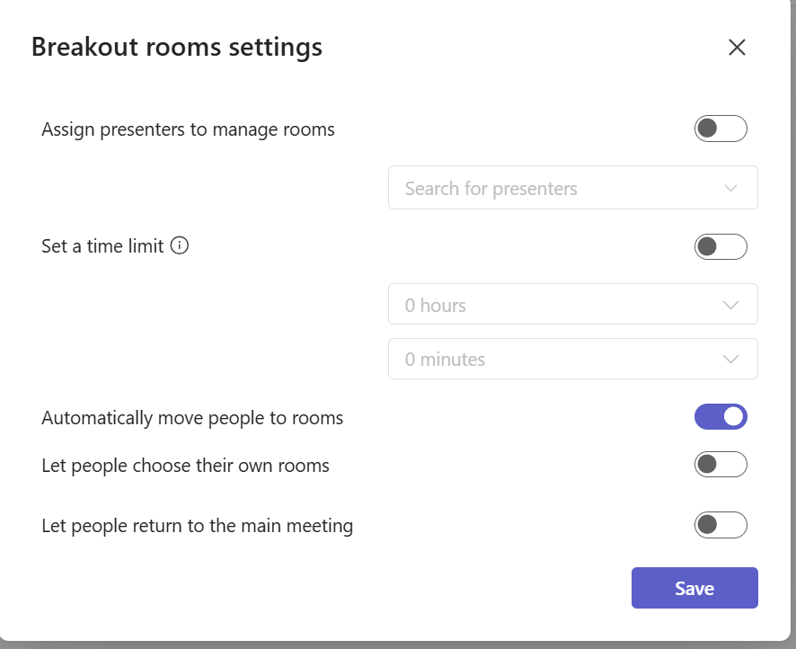  -Open the rooms. Participants will automatically be put in a room in 10 seconds, or can click to join manually.  -If you enable timer, timer will count down and automatically close rooms, bring students back  - Meeting organizer sees chats in each breakout room, but participants will only see their room chat. | Watch VCC Tutorial
Engagement Features (polls, reactions) | Reactions, raise hand, and surveying | Use reactions, raise hand, and choose embedded polls app like Mentimeter. Mentimeter in Teams displays/interacts really well but need to create Menti in advance (can get a free account). *Unverified guests may have problems participating in polls. May be better to share external urls for Menti, Padlet or Sli.do polls or Microsoft Forms. The Polls app is often unreliable and requires the organizer to vote. | Watch VCC Tutorial for Polls and Mentimeter
Annotation | Annotate Tools | The organizer/presenter can annotate in “Live PowerPoint” share or in “Screen” share.  Participants can only annotate, in “share screen” mode (not window or PPT live share), and organizer must turn on annotate option. | Watch Tutorial
Whiteboard | Zoom Whiteboard | Microsoft Whiteboard provides collaborative work space. Can prepare in advance or start during meeting. Many templates available. Can open in browser window while you stay in Teams meeting. Can only export as image. DOES NOT have pages like Zoom whiteboard. | Watch Tutorial
Recordings  & Transcripts | Record to cloud, then upload automatically to Kaltura | Recordings saved to your OneDrive>Recordings folder for 120 days; can be uploaded to Mediaspace, then embed in Moodle. *eLearning is working on an integration for Jan 2026.  When you start recording/transcription, all participants will be muted/cameras off until they give consent. **Unlike Zoom, you cannot record JUST the speaker and slides. You can however just do a transcript recording. Participants may have access to the recording automatically after if they are meeting invitees or all presenters.  *You can record breakout room sessions. Recordings are saved to the Organizer’s one drive, however participants in a particular breakout room have to be the one to start the recording. | Watch Tutorial
Chat | Can upload a screenshot, file from Dropbox, Google Drive, OneDrive, or computer | NO DIRECT MESSAGING within a meeting like Zoom. You can direct message an employee outside the meeting window in the Teams app. You can’t direct message a student, nor can a student direct message an instructor unless there is a Teams class channel created.  Can upload “cloud files” or “from device”. IF you share a file from OneDrive/ location students do not have permission for, it creates a read-only copy that participants can download and edit. Note that externals/unverified guests cannot download files. | Watch tutorial (VCC LinkedIn)
Attendance | Meeting attendance report | Review or download the attendance report (.xls file) for your Teams meeting. If you created a recurring meeting, you can access every attendance report for each instance of the recurring meeting. | Watch tutorial
Live captions | Closed captions | Individuals can turn on captions during meeting. Go to “more”, “language and speech”, “show live captions.” You can also turn this on a standard setting for every Teams meeting. | Watch captions tutorial
Video Spotlight and Focus mode | Spotlight and Focus mode | You can spotlight a video for everyone in the meeting, up to seven video feeds. You can use focus mode or show your students how to turn it on to improve their view options. | Watch Tutorial Focus mode
Screen Control | Screen Control | If you change a student’s role to “presenter” and they screen share, you can “request control” of their screen. If they “give control”, you can navigate. This can also be done in regular meetings where everyone has the same permission levels. | Watch screen control tutorial
Sign Language Interpreting |  | Teams has a specific sign language mode that interpreters and DHH individuals can turn on. Sign Language View provides more predictable, high resolution video, and allows users to prioritize up to two other signers’ videos for larger placement on center screen. For both participants who are Deaf Hard of Hearing and Sign Language interpreters, please follow these steps:  - Go to "... More" in the meeting panel  - Select ⚙ settings > accessibility  - Turn on sign language mode.  - Select if you are a Signer (participant) or Sign Language Interpreter.  - Close the accessibility panel. You should see a hand icon after your participant name. These settings will be remembered at future Teams meetings unless you change the settings  Participants can also use the spotlight mode in addition to this. | ASL Video about Sign Language Mode  Video about Sign Language Mode
Audio Troubleshooting |  | Try these resources: https://www.rrc.ca/its/help-resources/teams/microsoft-teams-audio-support/

Recommended Settings for Online Class in Teams
Teams regular new meeting default setting is PEOPLE IN MY ORG AND GUESTS can bypass the lobby and EVERYONE can present. This may not be ideal for your class. Overview of types of Teams meetings: meetings, classes, townhalls, webinars. Use the “meeting options” button to adjust these settings.
Under “Meeting Access”
- Who can bypass the lobby? “organizers/co-organizers” if you want a waiting room. Otherwise set to “Everyone”. Can also turn off the lobby once the class has started.
- Turn on “Verification Required”
Under “Roles”
- Who can present? Only organizers/co-organizers (unless students are regularly screen sharing). You can also change to give someone “presenter” status during a meeting.
Under “Participation”
- Meeting chat “In-meeting only”
- Turn on “Allow participants to edit display name”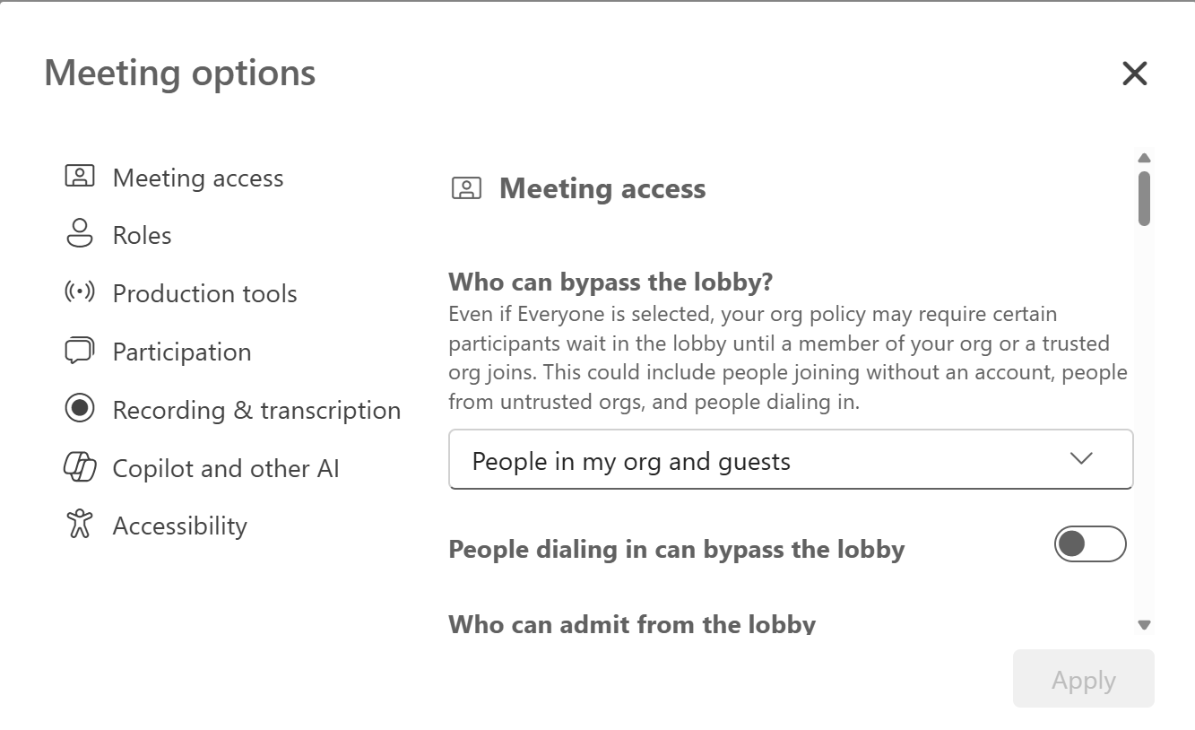

How to Verify your Teams Account

Log into Teams When Joining a Meeting
- If you are already logged into Teams somewhere on your computer when you click a Teams link, you will be automatically signed into Teams. Microsoft Edge works well for this.
- If you are not logged in anywhere on your computer when you click a meeting link, you will be prompted to enter your name or sign in. Click the Sign in link rather than manually entering your name and clicking the Join Now button.

Changing an Unverified Status when in a Teams Meeting
If you join a meeting without logging into Teams and notice that you are unverified:
- Exit the meeting by clicking the Leave button.
- A message should appear allowing you to Sign in
This Gettysburg College Teams help page provides helpful screenshots and description of the unverified user status and how to fix it.

If you want to require verification to join a teams meeting, but have an external attending, please add their email address as a “Presenter” in the meeting options for setup.
Additional Resources: Brock University Teams for Education Quick Guide: https://brocku.ca/pedagogical-innovation/wp-content/uploads/sites/53/TeamsforEducation_QuickGuide_Brock.pdf
Audio/Visual Troubleshooting: you can do a test call before a meeting. More audio troubleshooting: https://www.rrc.ca/its/help-resources/teams/microsoft-teams-audio-support

